PRESS RELEASE

Vifa: New Nordic brand for the passionate
music and design lover

Milan, April 8, 2014

Decades of refined craftsmanship within loudspeaker technology is weaved with Nordic design in Vifa’s global launch as a new audio brand. Copenhagen is the first wireless loudspeaker in a series to be launched over the next few years. The series has been designed for anyone who values exclusive design just as much as authentic sound.

The launch of Vifa as a new audio brand builds on a proud heritage. Soon after Vifa started in the early 1930’s in Denmark, the company became a preferred supplier of loudspeaker units for a number of well-known, high-end audio brands and kept that position into this century. Copenhagen weaves the years of technical expertise and craftsmanship with a functional and aesthetic approach based on the Nordic design tradition. Respect for materials, for details, and for the music is the keynote in the design of Copenhagen.

NORDIC DESIGN
Copenhagen’s Nordic design is reflected in its simple, organic lines and the choice of textile. Contrasts interplay with each other; the warm, rough ‘look and feel’ of the textile against the smooth, matte polished aluminum frame. The discretely embossed logo and embroidered volume buttons complement the understated look of Copenhagen. Copenhagen is wireless and portable and thus supports mobility as well as easy integration into the home.

AUTHENTIC SOUND
Creating authentic sound – a sound that is true to the original piece of music – is a matter of orchestration. It’s the art of making the finest components and technology play together. Only human talent and experience, the love of music, and an uncompromising attitude to quality create authentic sound. This is Vifa’s philosophy and the reason why quality-conscious music and design lovers will be thrilled by the sound of Copenhagen, both for peaceful everyday moments and for celebration.

COLORS
Copenhagen comes in six selected colors; each with their own, vibrant character: Sunset Red, Sand Yellow, Ocean Blue, Ice Blue, Anthracite Grey, and Pebble Grey. The textile cover is eco-friendly produced high-quality wool from Kvadrat, Europe’s leading manufacturer of design textiles. The fabric has a very high light fastness and resistance to pilling.

FEATURES
Copenhagen is connected via Bluetooth (aptX), Apple AirPlay or dlna (supports Wi-Fi Direct) to almost any cell phone, tablets and PCs/Macs. If the source of music does not support wireless transmission, an analogue or optical connection to Copenhagen can be made via the enclosed cables. The rechargeable, built-in battery allows for free placing of Copenhagen. The loudspeaker is simple to use and requires no pre-setting. For specific preferences, Copenhagen can be adjusted with the free Vifa app, which can be downloaded (iOS app available now / Android app coming soon).

DESIGN AWARDS
Copenhagen has been awarded with two internationally recognised Design Awards.
The IF Design Award and the Red Dot Design Award, both in the category for best product design 2014.

PRICE AND DISTRIBUTION
Copenhagen will be available at www.vifa.dk and through selected dealers (Summer 2014).
Recommended retail price: 899 EUR (incl.VAT).

PRESS MATERIAL AND IMAGES
Press releases and high-/low resolution images can be downloaded at:

http://www.vifa.dk/press - Login: design

For more information please contact: Lena Hansen, Marketing Manager.
Phone +45 2613 7009 / Email: leh@vifa.dk

Vifa is an international manufacturer of wireless and portable high-quality loudspeakers in an exclusive Nordic design. Vifa was founded in the early 1930’s in Denmark and soon became a preferred supplier of loudspeaker units for well-known high-end audio brands. Today, Vifa is an independent audio brand, developed and designed in Denmark.

Please visit www.vifa.dk for more information.

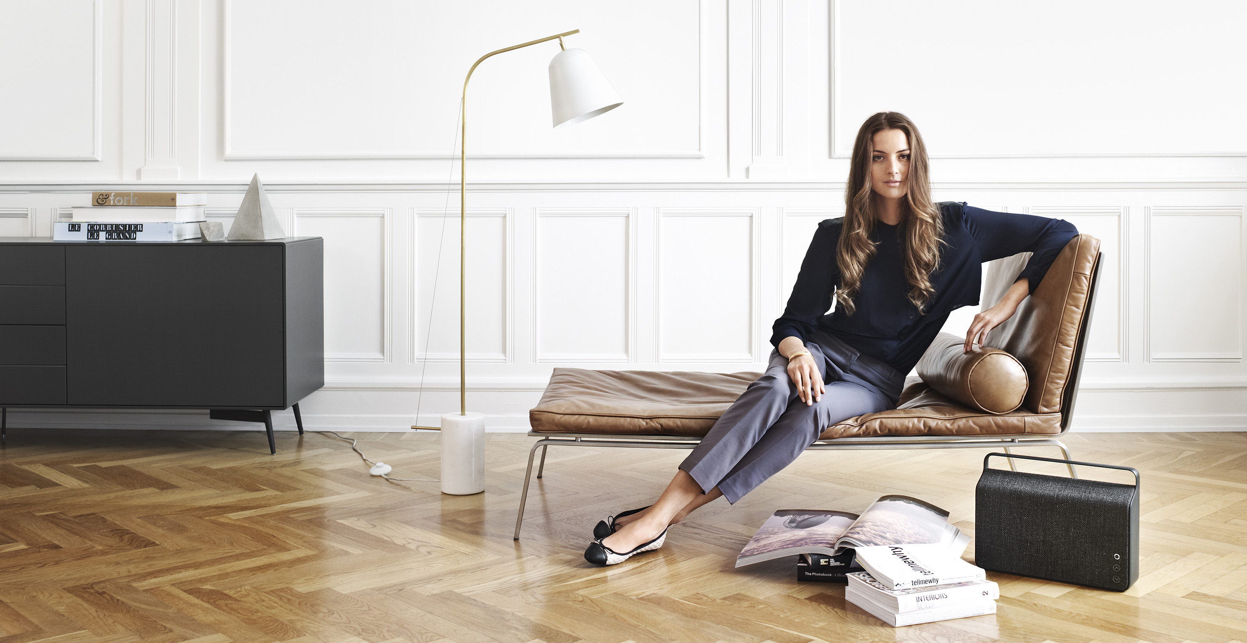



FOLLOW US:

FACEBOOK
www.facebook.com/vifa.dk

TWITTER
www.twitter.com/vifadk

PINTEREST
www.pinterest.com/vifadk

INSTAGRAM
www.instagram.com/vifadk

#Vifadk
#VifaCopenhagen

